Proposal to avoid lost productivity and save money using nomis

How to save time and money using existing systems.

Saunders, John  
HMP/YOI Moorland

Bawtry Road

Doncaster

DN7 6BW

Background

Nomis is the most used tool in the prison service and in my opinion is inefficient and has a poor user interface. It takes too much time and too many clicks of the mouse to access the relevant data that the majority of people want to access.

To this end I have conducted an experiment to find out how much time is being wasted on a daily, weekly, monthly and yearly basis.

I believe that there is a huge loss in productivity in this area of our work and it could potentially save time and money by making minor alterations to the user interface and the options presented to the end user at certain stages of the use cycle.

The Experiment

Based on 2 seconds per click to get from log in to prisoner data there are as a minimum 5 clicks then potentially more to get to the most accessed data. That data being financials, positive / negative entries, CSRA level or IEP level.

For the benefit of this experiment I will use the base data of 2 clicks per second and 5 clicks to access the data.

Then I am basing the next data set on an average day and the repeated process on different wings.

If you take into account Houseblock 1-4 have three wings 5 and 6 have two and induction one so at a minimum not including areas such as finance, OMU and segregation the potential number of times the information could be accessed is 18 times one for each wing and repeated 10 times in a 24 hour period for CSRA’s, account checks or applications.

After asking people on various Houseblocks working in these areas the consensus is that it is somewhat higher than this but for the purpose of the experiment I have decided that the resulting figures are convincing enough without adding to them.

10 seconds to get from log in to the main page (Case notes) less 2 ~Seconds that I propose after changes it will take.

10 uses x 8 seconds extra = 80 seconds

80 seconds x 18 wings = 1440 seconds / 60 min = 24 min per day / 2.8 hours a week / 11.2 hours a month / 134.4 hours or 5.6 days a year wasted productivity that could be avoided

These figures are based on a person who is computer literate and familiar with the system, executing commands at 2 seconds per click. Potentially the click time could be as much as 6 seconds for someone who is less computer literate or not familiar with the system in which case the time save could be dramatically different (16.8 days per year).

Research Conducted

**Identify the Biggest Waste to Increase Productivity**

The biggest waste in most companies, whether service, distribution or manufacturing, is wasted chronological time. In the 4-part series “The Fabric of the Cosmos”, physicist Brian Greene explains the science behind Einstein’s theory of relativity, which makes time travel possible. While physicists debate the theoretical fine points, time marches forward in an unstoppable fashion for the rest of us. Each second ticking by, gone forever, never to be recaptured. Time only moves forward, never backward. When we allow the minutes to pass by without productive effort, we lose them forever.

The prison service have not addressed this and are allowing those seconds, minutes and hours to tick by without concern for productivity. The biggest waste is a constant struggle, A second may not seem like a significant time loss but imagine if every mouse click took two seconds instead of one second. The slow response means we can only do half as many mouse clicks in a day, which literally means we can only do half as much work in a day. In many companies, worker productivity is only one half or even one third of what it actually could be and should be.

From another perspective, imagine if the Prison service could be twice as productive with the same number of employees and the same amount workers and the same capital investment in equipment. When we start thinking in these terms, the true implications of wasted time become quite clear and begin open our eyes to all kinds of possibilities.

**Poor Productivity is Wasted Time**

If we say productivity is only half what it should be and if we say poor productivity is due primarily to wasted chronological time, then wasted time is clearly the biggest waste experienced by any non-lean company. This waste is far bigger than all the other wastes in the company combined, making it the most detrimental. If this truly is the biggest waste, then it seems reasonable to propose improvement initiatives that reduce time wasting activities and tasks. However, this is rarely the case. Maybe people do not want the improvement, or even feel threatened by it. It seems like a harsh thing to say but the truth is, if productivity were to double overnight, most companies could not sell the extra capacity, raising an entirely new issue but in the prison service this is not the case and much more could be achieved if alterations could be made to reduce the high proportion of wasted time using the basic tools we have at our disposal.

Suggested Changes

These changes are suggested because they should be easy to implement and are based on what the majority of user’s use the system for and will cut out a high volume of wasted clicks.

This would allow access to the basic data which a user would generally want to see when first accessing the system and to potentially eliminate up to 20 clicks and display all vital data that would generally be accessed in one use cycle on one page and to greatly improve the systems efficiency.

When a user first logs into Nomis 99% of users want to find a prisoner but the first screen you see is blank. Then you have to go to name search and select your prisoner and nothing happens. Then you have to go to case notes to get a basic set of information which has little structure other than a chronological list of occurrences which is fine if you don’t want to find anything specific but usually the user is looking for one or more of the following:

* CSRA level and specific details
* Positive entries
* Negative entries
* Financials
* Release date
* Adjudications
* Alerts
* IEP Level
* Name, Number and Location
* Smoking status
* Visits booked and allowance
* Ethnic Code
* Picture of the prisoner

To make the process of accessing this data less fragmented and to save time it would be my recommendation to display the search page automatically upon log in and to redesign the hot page making it the second page you see once you select the prisoner from the search. Below is a graphical representation of how this would be achieved.

Old Process (some details have been removed for confidentiality)

Initial screen

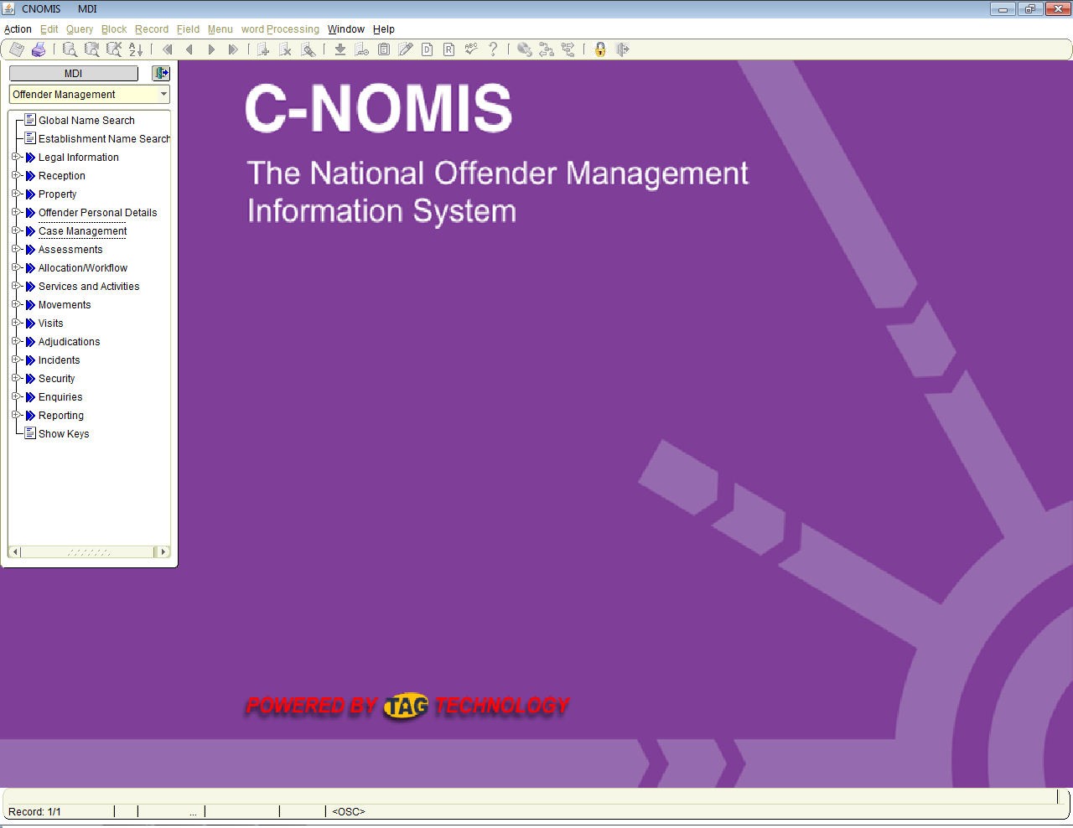

Then Search and click perform task

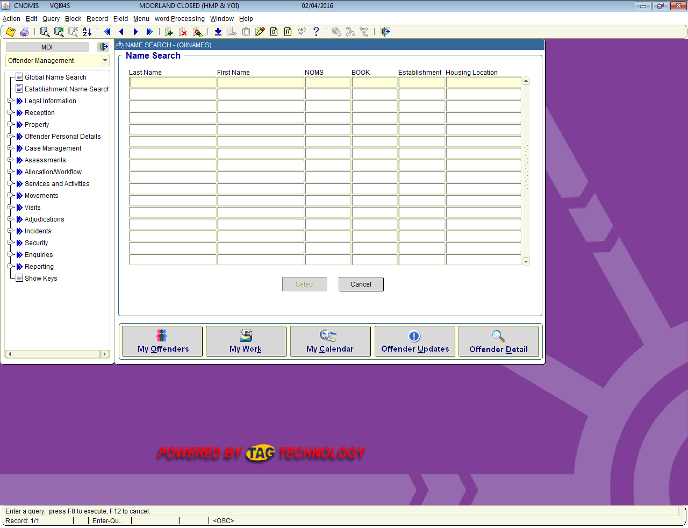

Click Select prisoner

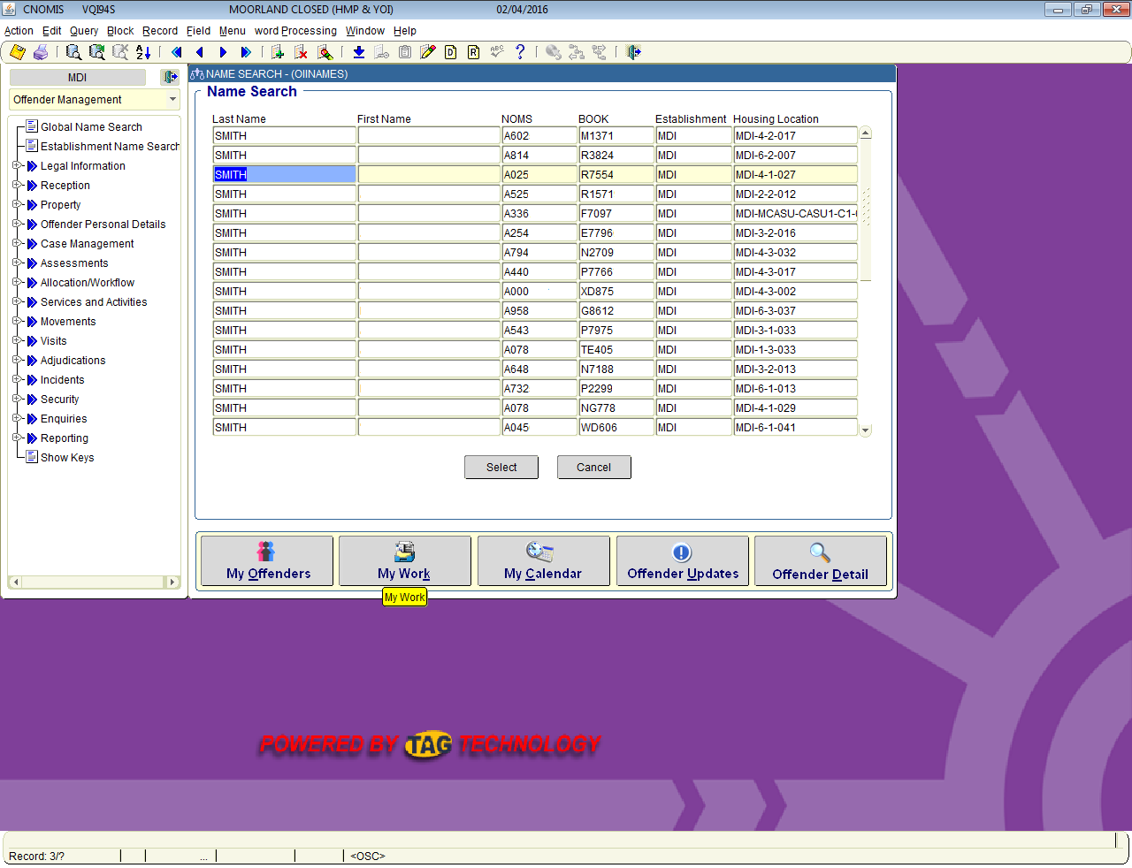

Once selected you are presented with a random blank page with no information

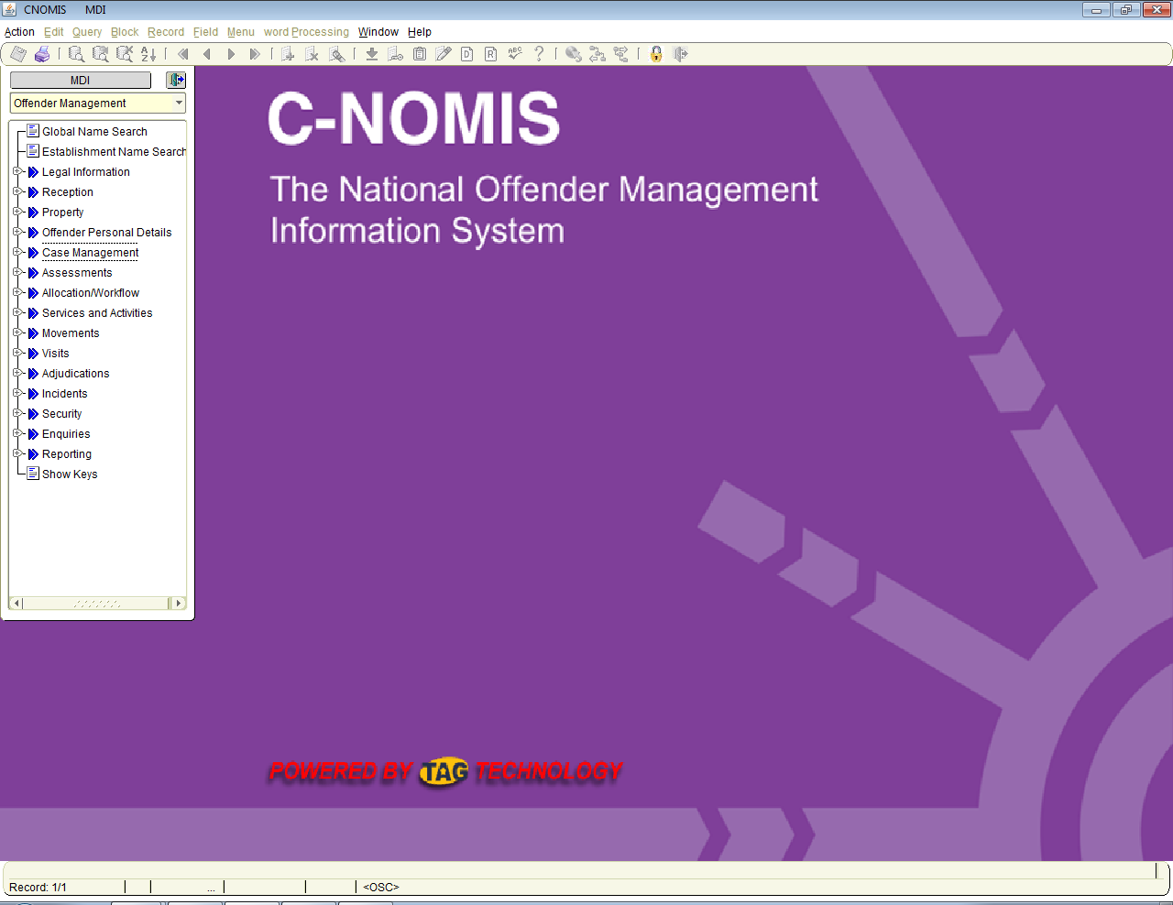

Now navigate to case notes and click to expand and click again to access case notes

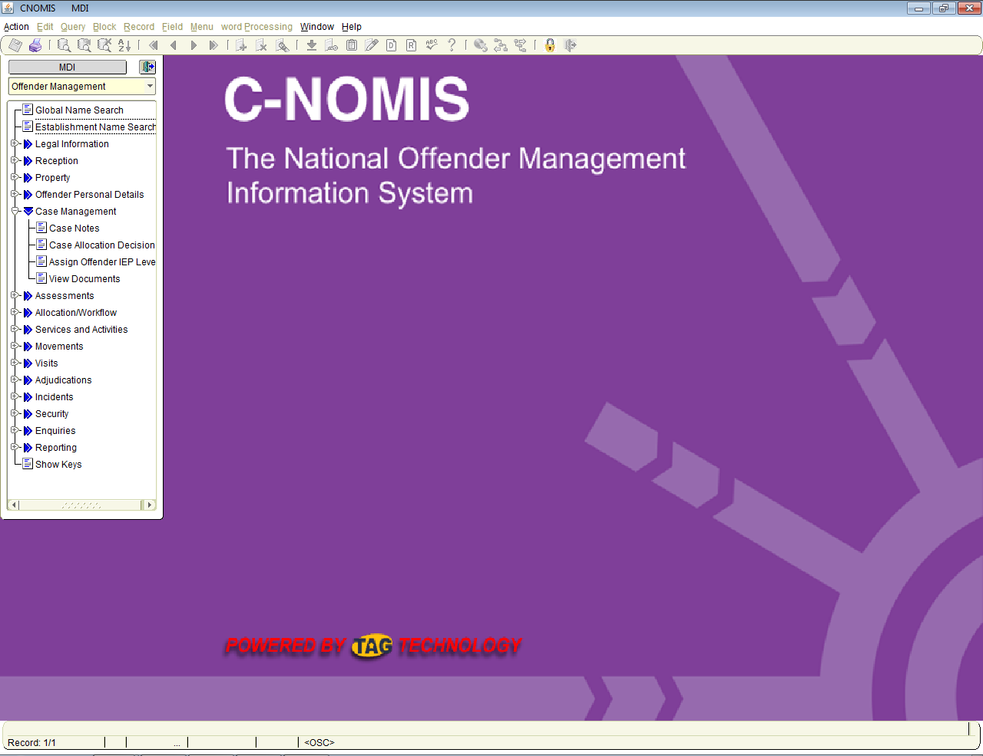

You are now presented with limited information in chronological order and some personal data with no description as to what it is without navigating further.

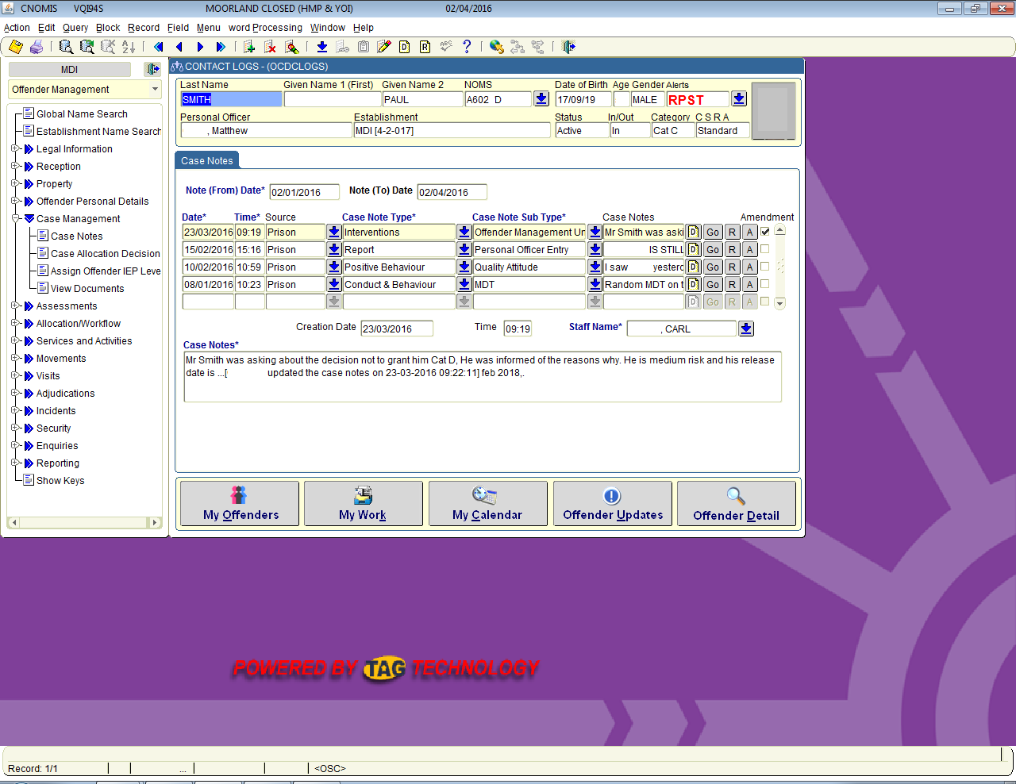

Now click hot page to get some more limited information

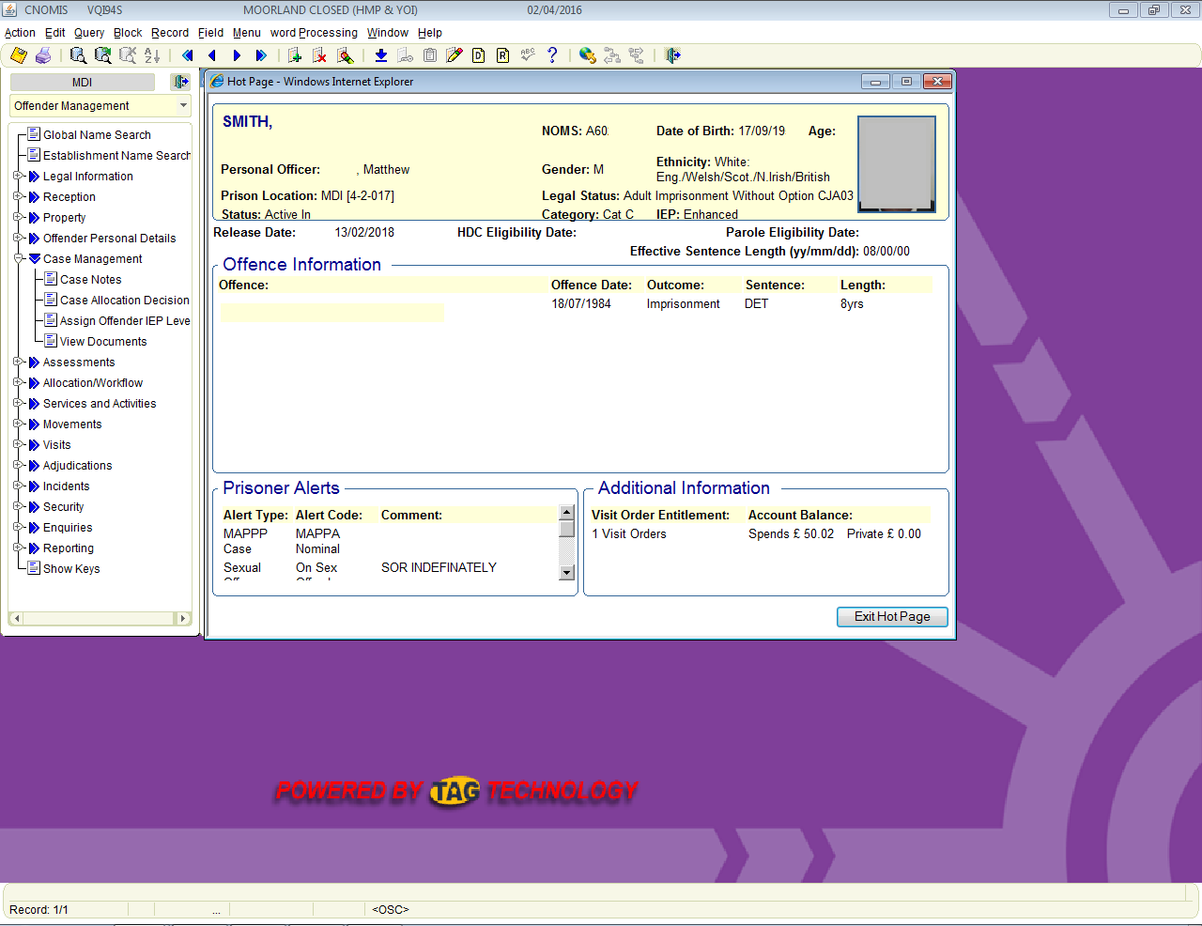

This process is long drawn out and inaccurate as not all of the data sets are descriptive enough. To find information on for example negative entries there are many more clicks involved and to find out CSRA details you have to navigate to an entirely different screen.

Proposed way

The first screen the majority of people need is the search screen so on log in display this first rather than a blank page.

Search results will be displayed in the same fashion.

Upon clicking the select button the next page to be displayed automatically would be a redesigned Hot Page which could potentially look like this.

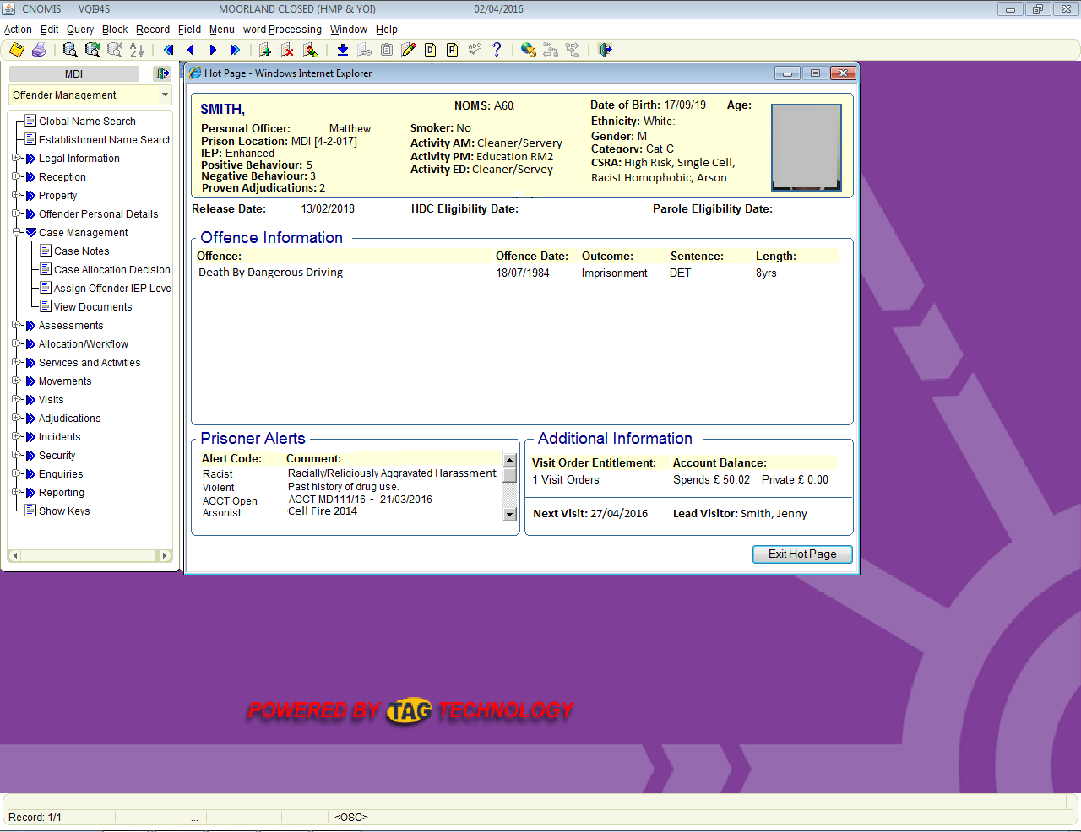

As you can see all relevant information is listed without having to navigate to any other page.

Alterations have been made to the alerts section listing the type of alert and the first 4 words of the description to give a brief overview of the alerts. If any more information should be required it could be sourced from the main alerts section however in most circumstances this information should be sufficient.

The visits section now includes the next booked visit date and the lead visitor.

The main information panel for the prisoner now includes CSRA level and description, the number of positive and negative entries in the last 3 months, the number of proved adjudications in the last 3 months, AM, PM and ED activity slots, Smoking status and all the previous hot page information from the old format.

This would allow a member of staff to get all relevant information to the majority of enquiries instantly without having to hunt around numerous pages to acquire it. It would also assist in CSRA reviews, IEP reviews and finance enquiries letting the user see the information required at a quick glance rather than having to scroll down a chronological list of irrelevant information.

Attached in the email with this document is a full size picture of the new Hot Page layout so you can see it in full size.